Unit Five: Exploring the Mystery

Lesson 17: Oceans and Deserts

1. Choose the answer that best explains the underlined word or part.
2. It was hard to hear *amidst* all the cheering.
3. in the middle of
4. on
5. in the stage
6. The butterflies *circulated* in the sky.
7. moved back and forth
8. moved straight
9. moved round and round
10. I left home *immediately* after lunch.
11. slowly
12. quickly
13. directl
14. Scientists *experiment* the components of a solution in the laboratory.
15. write
16. study
17. create
18. Fill in the blanks with words from the box to complete each sentence.

|  |  |  |  |  |
| --- | --- | --- | --- | --- |
| small | frightened | plain | important | hot |

1. When someone is afraid of something, he is ____________________
2. The weather in tropical places is __________________
3. Water is very ________________for the growth of a plant.
4. The field is ________________ piece of land.
5. I cut the vegetables into __________________ pieces.
6. Add ‘er’ and ‘est’ to each adjective.

|  |  |  |
| --- | --- | --- |
| **Adjective** | **Adjective + er** | **Adjective + est** |
| bright |  |  |
| high |  |  |
| small |  |  |
| hungry |  |  |
| cool |  |  |
| thin |  |  |

1. **Add ‘er’ or ‘est’ to the adjective to complete each sentence correctly.**
2. The weather in spring is (warm) ___________________ than winter.
3. I live in the (tall) ___________________ in the town.
4. My hair is (long) ___________________ than my sister’s hair.
5. The water in tropical places is the (hot) ________________ of all.
6. My English teacher is the (kind) ____________________ person I have ever met.
7. My friend’s truck is (big) ___________________ than ours.

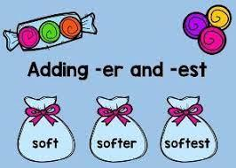

1. Fill in the blanks with words from the box to complete the paragraph.

|  |  |  |  |  |  |
| --- | --- | --- | --- | --- | --- |
| salt | Antarctic | surface | water | world | Atlantic |

Ocean is a huge body of _______________water. Oceans cover nearly 71 percent of Earth's ________________. They contain almost 98 percent of all the _______________on Earth. There is one _______________ocean, but it is divided into five main areas: the Pacific, the, the Indian, the Arctic, and the Southern, or ________________.

1. Just-for-fun! Solve these riddles.
2. I move in the ocean. I have an oval body and two arm-like things on my sides, but I am not a fish. Who am I? _______________________
3. There are five of me. We cover most of the earth. What are we? _______________________
4. You hear me when a cliff or hill reflects the sound. What am I? _______________________

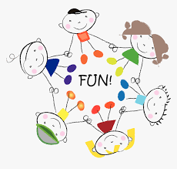

Read the text above.

Sunlight doesn’t reach deep in the ocean. Plants don’t grow down there. They only grow near the surface of the water. Small plants and other living things float on the surface of water and form a plankton. Marine animals feed on it.

In the deeper parts, the fish can't find enough food. Fish have different shapes, sizes and colors. They have lights to help them see in the dark. Their teeth are very sharp

Whales cannot live in the deep dark part of the ocean. They are mammals. They must come up out of the water to breathe because they have lungs and not gills. A whale can stay for around 75 minutes underwater.

1. Answer the following questions about the above text.
2. Why don’t plants grow deep down on the ocean floor?

_________________________________________________________________________

1. Why do whales come out of the water to breathe?

_________________________________________________________________________

1. Fill in the Venn Diagram to compare and contrast the whale and the fish based on the above text.

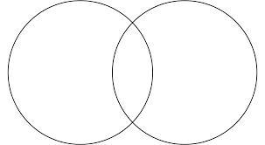

1. Draw a picture related to the above text, then write a short paragraph to summarize it.



________________________________________________________________________________________________________________________________________________________________________________________________________________________________________________________________________________________________________________________________________________________________________________________________________________________________________________________________________________________________________________________________________________________________________________________________________

1. Complete the words with one of the following digraphs: wh, ch, kn, wr, or ph.

|  |  |  |
| --- | --- | --- |
| _________ong | ___________oto | __________ange |
| _________ere | ___________ew | __________ite |
| _________ore | ___________ee | __________one |
| _________ife | ___________eck | ele__________ant |
| _________ale | ___________y | __________ow |

1. Answer the following questions using words and phrases from the box.

|  |  |  |  |  |  |  |
| --- | --- | --- | --- | --- | --- | --- |
| wrong | wrecked ship pieces | elephant | whales | photos | chores | oceanographers |

1. What do we call someone who studies the seas and oceans? ________________
2. What is the largest sea creature? _________________
3. What do they find on the ocean’s floor? _________________
4. Why do oceanographers use cameras? ___________________
5. What do oceanographers have to do in labs? _____________________

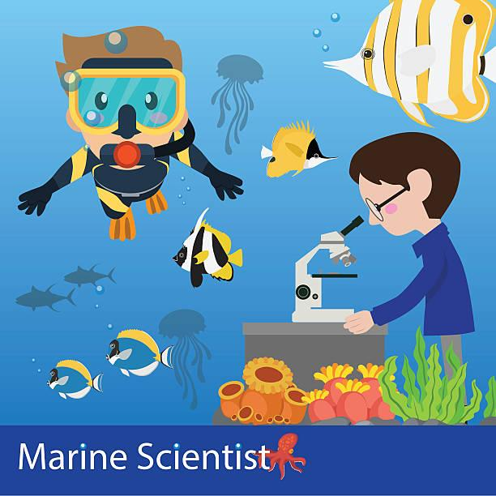

1. Use the prepositions from the box to complete the following sentences.

|  |  |  |  |  |  |
| --- | --- | --- | --- | --- | --- |
| with | on | of | at | in | to |

1. I went to the zoo _____________ my best friends.
2. We gathered ______________ our school ______________ 2:00 in the afternoon.
3. We put ______________ comfy clothes on so we can move easily.
4. The amount _____________ food we took was enough for us.
5. Use the following prepositions in complete sentences.
6. between: ________________________________________________________
7. from: ___________________________________________________________
8. through: _________________________________________________________
9. behind: __________________________________________________________
10. under: __________________________________________________________
11. Imagine you went on a trip on a ship to the oceans. Write a short paragraph describing that day, things you saw and did, and how you felt. Answer the questions below, then write the answers in the form of a paragraph.
12. When did you decide to go on a trip?

_________________________________________________________________________

1. Who did you go with?

_________________________________________________________________________

1. How did you feel at the beginning of your trip? Why?

_________________________________________________________________________

1. Describe things you saw, heard and smelled during your trip. Be creative and add as many details as you can.

____________________________________________________________________________________________________________________________________________________________________________________________________________________________________________________________________________________________________

1. What did you do with the people you went with?

__________________________________________________________________________________________________________________________________________________

1. How did you feel when you came back home? Why?

__________________________________________________________________________________________________________________________________________________

1. Use the answers from the above exercise to write a short paragraph about your trip.

____________________________________________________________________________________________________________________________________________________________________________________________________________________________________________________________________________________________________________________________________________________________________________________________________________________________________________________________________________________________________________________________________________________________________________________________________________________________________________________________________________________________________________________________________________________________________________________________________________________________________________________________________________________________________________

1. Draw a picture about your story.

